Accessing Senior Pictures for Class of 2025

Good afternoon, Parents/Guardians
We are excited to share the details for accessing your child’s senior pictures. Please follow the steps below:
- Click on the following link: https://shorturl.at/cD47d or scan the QR code below.
- Locate your child’s name and click on it.
- Enter the password (your child’s lunch number).
- Complete the form and submit it to Dr. Bruce Williams along with your payment (money order or cash).
Thank you for your cooperation!
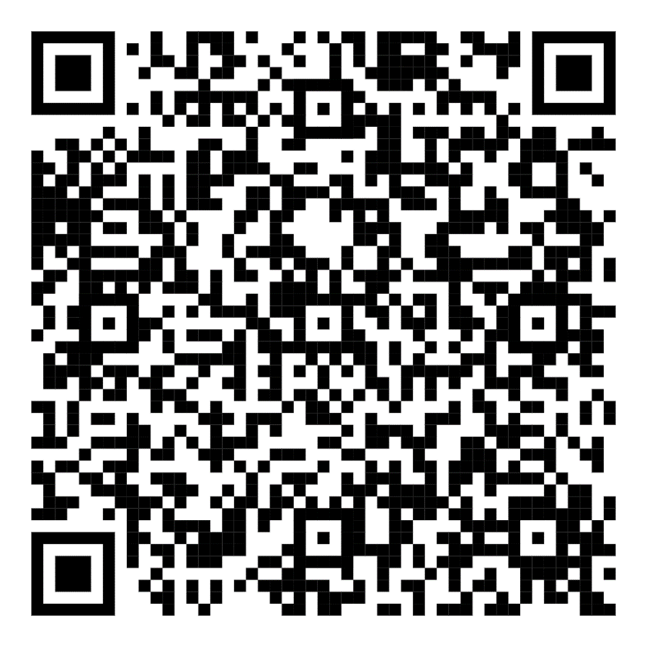
Qr Code Class of 2025

